SIMATS ENGINEERING

ASSESSMENT TOOL 3

COURSE NAME: DESIGN AND ANALYSIS OF ALGORITHMS
COURSE CODE: CSA0601

COURSE OUTCOME COVERED

CO2: Apply Brute Force technique to solve sorting, searching, Closest-Pair and Convex-Hull problems (BL1, BL2, BL3)

Assessment Tool Weightage: 10%

QUESTIONS: 10 Total Marks:50

Annexure A

DEBUGGING & OPTIMISATION TASK

Code of Conduct:

I _U.Prabhavathi/192472067 (Name / Reg No) certify that this submission is my original work and that I have adhered to the guidelines specified for this assessment.
I understand that any violation of academic integrity rules will result in disciplinary action.
U.Prabhavathi
Signature of the student:

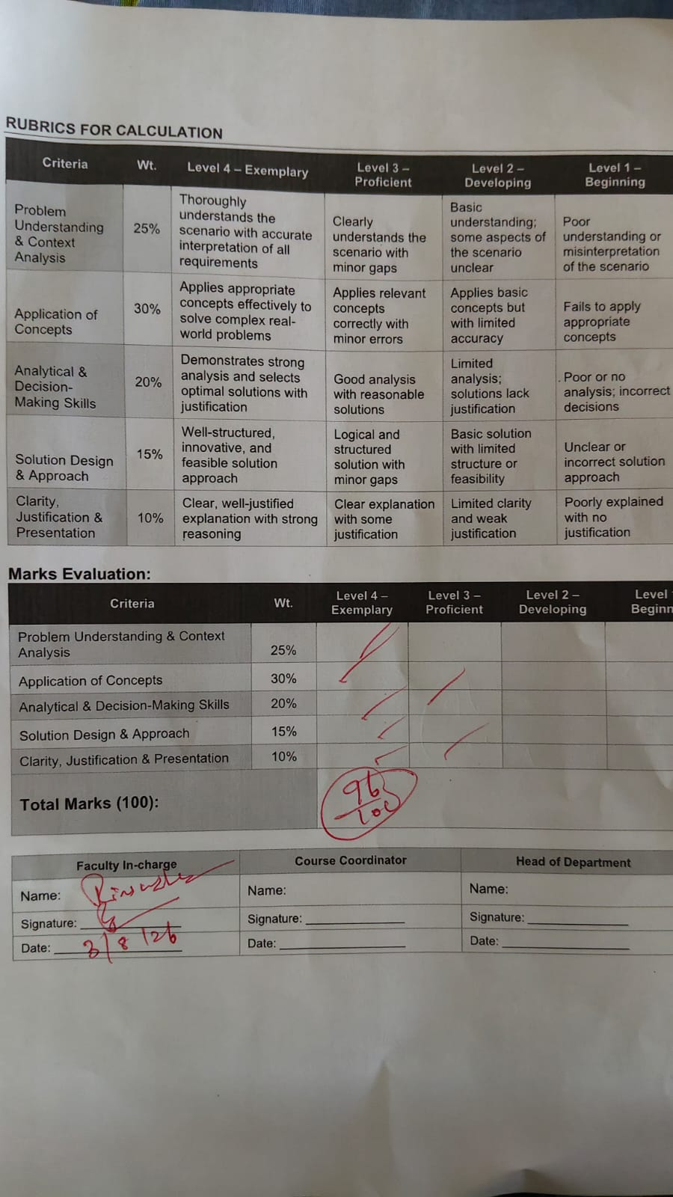

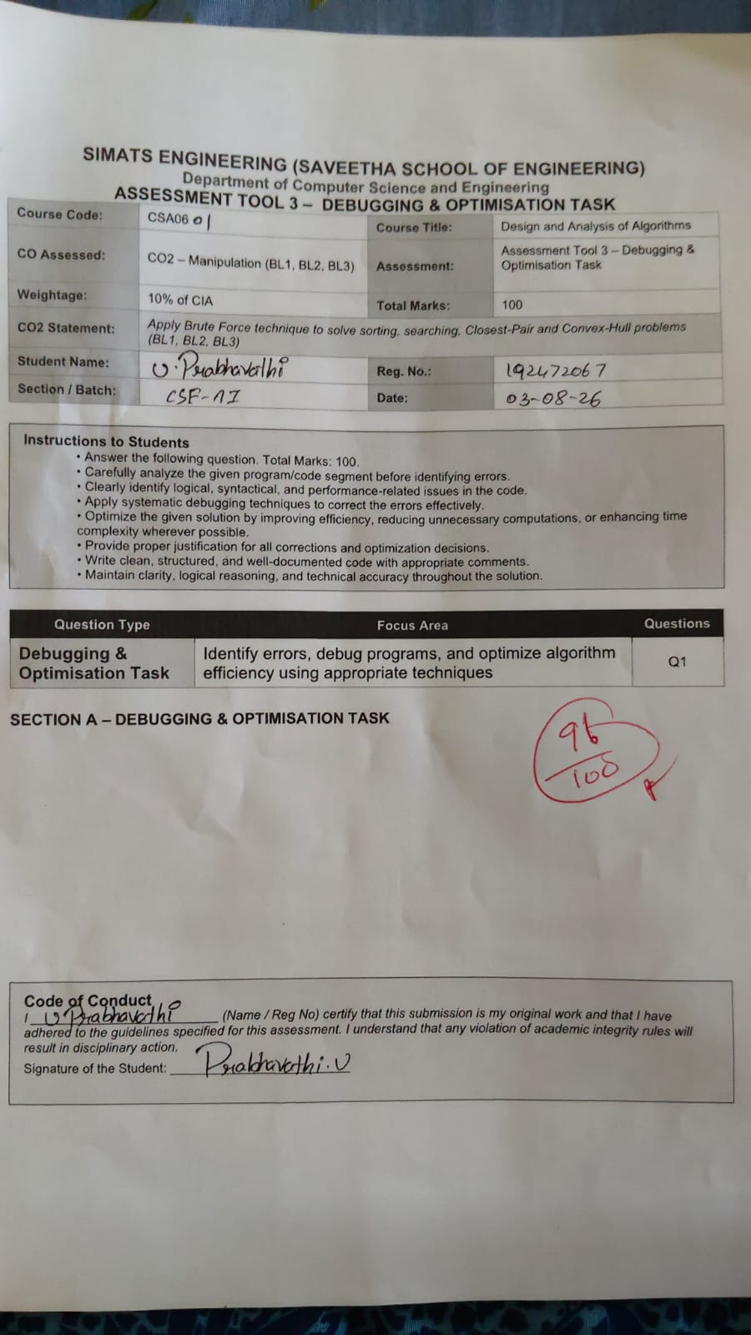

Annexure A

DEBUGGING & OPTIMISATION TASK
Q96. Debugging Convex Hull Orientation Logic (Sign Error in C)
The following orientation function used in a brute force Convex Hull implementation in C contains a sign-related logical issue that can reverse turn direction and cause interior edges to be treated as hull edges. Carefully analyze the formula and explain how incorrect orientation affects boundary detection. Debug the function so that clockwise, counterclockwise, and collinear cases are interpreted correctly in the hull logic. Optimize the overall reasoning by structuring the edge-validation check more clearly. Analyze the time complexity of the corrected brute force approach and rewrite the improved C code with suitable comments.
int orientation(int px, int py, int qx, int qy, int rx, int ry) {
return (qy - py) * (rx - qx) - (qx - px) * (ry - qy); // ISSUE
}
Q97. Debugging String Matching Code (Last Valid Alignment Skipped in C)
The following brute force string matching implementation in C skips the last valid starting position of the pattern in the text because of an incorrect outer loop bound. Carefully inspect the loop range and explain why one potential match is never examined. Apply systematic debugging so that every valid alignment from the first to the last possible position is checked correctly. Optimize the corrected implementation for readability while preserving the brute force method. Analyze the time complexity of the corrected version and rewrite the final C code with proper comments.
#include <stdio.h>
#include <string.h>
void stringMatch(char text[], char pattern[]) {
int n = strlen(text), m = strlen(pattern);
int i, j;
for (i = 0; i < n - m; i++) { // ERROR
for (j = 0; j < m; j++) {
if (text[i + j] != pattern[j])
break;
}
if (j == m)
printf("Match at %d\n", i);
}
}
Q98. Debugging Pair Sum Code (Redundant and Invalid Pair Checks in C)
The following brute force Pair Sum implementation in C checks all ordered pairs, including mirror pairs and self-pairs, which leads to redundant computation and may produce invalid solutions. Carefully analyze the nested loop structure and explain why each valid unordered pair should be considered only once using distinct indices. Debug the code so that redundant and invalid comparisons are eliminated without missing any correct answer. Optimize the implementation for cleaner structure and reduced unnecessary checks. Analyze the time complexity of the corrected solution and rewrite the final C code with proper comments.
int pairSum(int arr[], int n, int target, int *a, int *b) {
int i, j;
for (i = 0; i < n; i++) {
for (j = 0; j < n; j++) { // ISSUE
if (arr[i] + arr[j] == target) {
*a = i;
*b = j;
return 1;
}
}
}
return 0;
}
Q99. Debugging Maximum Element Search Code (Unsafe Initialization in C)
The following C function attempts to find the maximum element in an array, but it initializes the maximum value to zero, which causes incorrect results when the array contains all negative values. Carefully analyze the initialization step and explain why it breaks correctness for certain input categories. Apply systematic debugging so that the maximum is initialized safely from the data itself and the code handles invalid input appropriately. Optimize the corrected implementation for robustness and clarity. Analyze the time complexity of the corrected solution and rewrite the final C code with suitable comments.
int findMax(int arr[], int n) {
int i, maxVal = 0; // ERROR
for (i = 0; i < n; i++) {
if (arr[i] > maxVal)
maxVal = arr[i];
}
return maxVal;
}
Q100. Debugging Insertion Sort Code (Incorrect Final Placement Index in C)
The following Insertion Sort implementation in C shifts larger elements correctly, but it places the key back into the wrong array index after the shifting loop ends, which causes misplaced elements and breaks ascending order. Carefully analyze the role of j after the loop terminates and explain why the final insertion must occur at the next valid position. Debug the code step-by-step so that the key is inserted exactly where the sorted prefix requires it. Optimize the corrected implementation for readability and consistent indexing. Analyze the corrected algorithm in terms of time complexity and rewrite the final clean C code with proper comments.
void insertionSort(int arr[], int n) {
int i, j, key;
for (i = 1; i < n; i++) {
key = arr[i];
j = i - 1;
while (j >= 0 && arr[j] > key) {
arr[j + 1] = arr[j];
j--;
}
arr[j] = key; // ERROr

Q96. Debugging Convex Hull Orientation Logic (Sign Error in C)

a) Problem Analysis
The orientation function determines whether three points make:
- Clockwise turn
- Counterclockwise turn
- Collinear
The given code is:
int orientation(int px, int py, int qx, int qy, int rx, int ry) {
return (qy - py) * (rx - qx) - (qx - px) * (ry - qy); // ISSUE
}
The formula is incorrect because it uses vectors PQ and QR instead of the standard cross product based on P. This can reverse the turn direction and incorrectly classify hull edges.

b) Debugging
Correct orientation formula:
(qy−py)(rx−qx)−(qx−px)(ry−qy)(q_y-p_y)(r_x-q_x)-(q_x-p_x)(r_y-q_y)(qy​−py​)(rx​−qx​)−(qx​−px​)(ry​−qy​)
can be simplified into the standard cross product:
(qx-px)*(ry-py) - (qy-py)*(rx-px)
Interpretation:
- Positive → Counterclockwise
- Negative → Clockwise
- Zero → Collinear
During Convex Hull construction:
- Every remaining point must lie on the same side of the selected edge.
- Otherwise, the edge is not part of the hull.

c) Time Complexity
Outer pair selection = O(n²)
Checking all remaining points = O(n)
Overall complexity:
O(n³)
Space Complexity:
O(1)

d) Correct C Program
#include <stdio.h>

// Returns:
// 0 -> Collinear
// 1 -> Clockwise
// 2 -> Counterclockwise

int orientation(int px,int py,int qx,int qy,int rx,int ry)
{
int val=(qx-px)*(ry-py)-(qy-py)*(rx-px);

if(val==0)
return 0;
else if(val>0)
return 2;
else
return 1;
}

Q97. Debugging String Matching Code (Last Valid Alignment Skipped)

a) Problem Analysis
Original code
for(i=0;i<n-m;i++)
Suppose
Text = "ABCDE"
Pattern = "DE"
n = 5
m = 2
Last valid position
5−2=35-2=35−2=3
Loop executes
i=0
i=1
i=2
Position 3 is skipped.
Hence the last possible match is never checked.

b) Debugging
Correct loop
for(i=0;i<=n-m;i++)
Now every valid alignment is examined.

c) Time Complexity
Outer loop
O(n−m+1)
Inner loop
O(m)
Worst case
O(nm)
Space
O(1)

d) Correct Program
#include<stdio.h>
#include<string.h>

void stringMatch(char text[],char pattern[])
{
int n=strlen(text);
int m=strlen(pattern);
int i,j;

for(i=0;i<=n-m;i++)
{
for(j=0;j<m;j++)
{
if(text[i+j]!=pattern[j])
break;
}

if(j==m)
printf("Pattern found at index %d\n",i);
}
}

int main()
{
char text[]="ABCDEFABC";
char pattern[]="ABC";

stringMatch(text,pattern);

return 0;
}

Q98. Debugging Pair Sum Code

a) Problem Analysis
Original code
for(i=0;i<n;i++)
{
for(j=0;j<n;j++)
Problems
- Checks (2,5) and (5,2)
- Checks self pair
arr[3]+arr[3]
These comparisons are unnecessary.

b) Debugging
Use
for(j=i+1;j<n;j++)
Benefits
- No duplicate pairs
- No self-pairs
- Every unordered pair checked once

c) Time Complexity
Number of comparisons
n(n−1)2\frac{n(n-1)}22n(n−1)​
Time Complexity
O(n²)
Space Complexity
O(1)

d) Correct Program
#include<stdio.h>

int pairSum(int arr[],int n,int target,int *a,int *b)
{
int i,j;

for(i=0;i<n;i++)
{
for(j=i+1;j<n;j++)
{
if(arr[i]+arr[j]==target)
{
*a=i;
*b=j;
return 1;
}
}
}

return 0;
}

int main()
{
int arr[]={2,7,11,15};
int a,b;

if(pairSum(arr,4,9,&a,&b))
printf("Pair found at index %d and %d",a,b);
else
printf("Pair not found");

return 0;
}

Q99. Debugging Maximum Element Search Code

a) Problem Analysis
Original code
int maxVal=0;
Suppose
-10
-20
-5
Largest value
-5
Program returns
0
which is incorrect because 0 is not present in the array.

b) Debugging
Initialize maximum with the first array element.
maxVal=arr[0];
Also check
n<=0
to avoid invalid input.

c) Time Complexity
Array scanned once.
Time Complexity
O(n)
Space Complexity
O(1)

d) Correct Program
#include<stdio.h>

int findMax(int arr[],int n)
{
if(n<=0)
return -1;

int i;
int maxVal=arr[0];

for(i=1;i<n;i++)
{
if(arr[i]>maxVal)
maxVal=arr[i];
}

return maxVal;
}

int main()
{
int arr[]={-10,-25,-3,-40};

printf("Maximum=%d",findMax(arr,4));

return 0;
}

Q100. Debugging Insertion Sort Code

a) Problem Analysis
Original code
arr[j]=key;
After shifting,
j
becomes one position before the correct insertion point.
Therefore
arr[j]
is incorrect.
The key must be placed at
arr[j+1]

b) Debugging
Correct statement
arr[j+1]=key;
This inserts the key exactly after the last smaller element.

c) Time Complexity
Best Case
Already sorted
O(n)
Average Case
O(n²)
Worst Case
Reverse sorted
O(n²)
Space Complexity
O(1)

d) Correct Program
#include<stdio.h>

void insertionSort(int arr[],int n)
{
int i,j,key;

for(i=1;i<n;i++)
{
key=arr[i];
j=i-1;

while(j>=0 && arr[j]>key)
{
arr[j+1]=arr[j];
j--;
}

arr[j+1]=key;
}
}

int main()
{
int arr[]={9,5,1,4,3};
int n=5,i;

insertionSort(arr,n);

printf("Sorted Array:\n");

for(i=0;i<n;i++)
printf("%d ",arr[i]);

return 0;
}

RUBRICS FOR CALCULATION

DEBUGGING & OPTIMISATION TASK

Criteria | Weightage | Level 4 (Exemplary) | Level 3 (Proficient) | Level 2 (Developing) | Level 1 (Beginning)
Problem Identification | 20% | Accurately identifies all errors and root causes with clear understanding | Identifies most errors with minor gaps | Identifies some errors but misses key issues | Unable to identify errors correctly
Debugging | 25% | Applies systematic debugging techniques effectively to resolve issues | Uses appropriate debugging methods with minor errors | Limited debugging approach; requires guidance | Unable to debug or resolve issues
Optimization | 20% | Optimizes code by significantly improving time complexity using efficient algorithms | Improves time complexity with minor gaps in efficiency | Limited improvement in time complexity | No improvement; inefficient approach retained
Analysis | 20% | Demonstrates strong logical reasoning and clear justification of solutions | Shows reasonable analysis with some justification | Limited analysis; weak reasoning | No analytical reasoning demonstrated
Code Quality | 15% | Produces clean, well-structured code with proper comments and documentation | Code is mostly clear with minor documentation gaps | Code lacks structure and proper documentation | Poorly written code with no documentation

